Lab Assignment 4

**Lab 4 (A) Peter.s**

Source Code

##

## The program --- Peter.s

##

## - will ask the user for his/her name,

## - will ask the user for age,

## - print the name and age.

##

## a0 - points to output strings

## v0 - reads integer

## t0 - holds integer

#################################################

# #

# text segment #

# #

#################################################

.text

.globl __start

__start: # execution starts here

la $a0, printNameQ #print on terminal

li $v0,4 #system call to print

syscall #a string of a question

la $a0, scanName #system call to

li $a1, 80 #read the string

li $v0, 8 #the string

syscall

la $a0, printName #print prompt on terminal

li $v0,4 #system call to print

syscall #a string

li $v0,5 #system call to

syscall #read an integer

add $t0,$t0,$v0 #store the integer

la $a0, scanName #print on terminal

li $v0, 4 #system call to print

syscall #a string

la $a0, sent1 #prints string after

li $v0,4 #printing name

syscall

move $a0,$t0 #system call to

li $v0,1 #print age

syscall

la $a0, sent2 #prints string after

li $v0,4 #printing age

syscall

li $v0,10 #Exit

syscall #Bye!

#################################################

# #

# data segment #

# #

#################################################

.data

printNameQ: .asciiz "Hello, what is your name? "

scanName: .space 80

printName: .asciiz "How old are you? "

sent1: .asciiz "is "

sent2: .asciiz " years old."

#

# end of file Peter.s

Successful Load

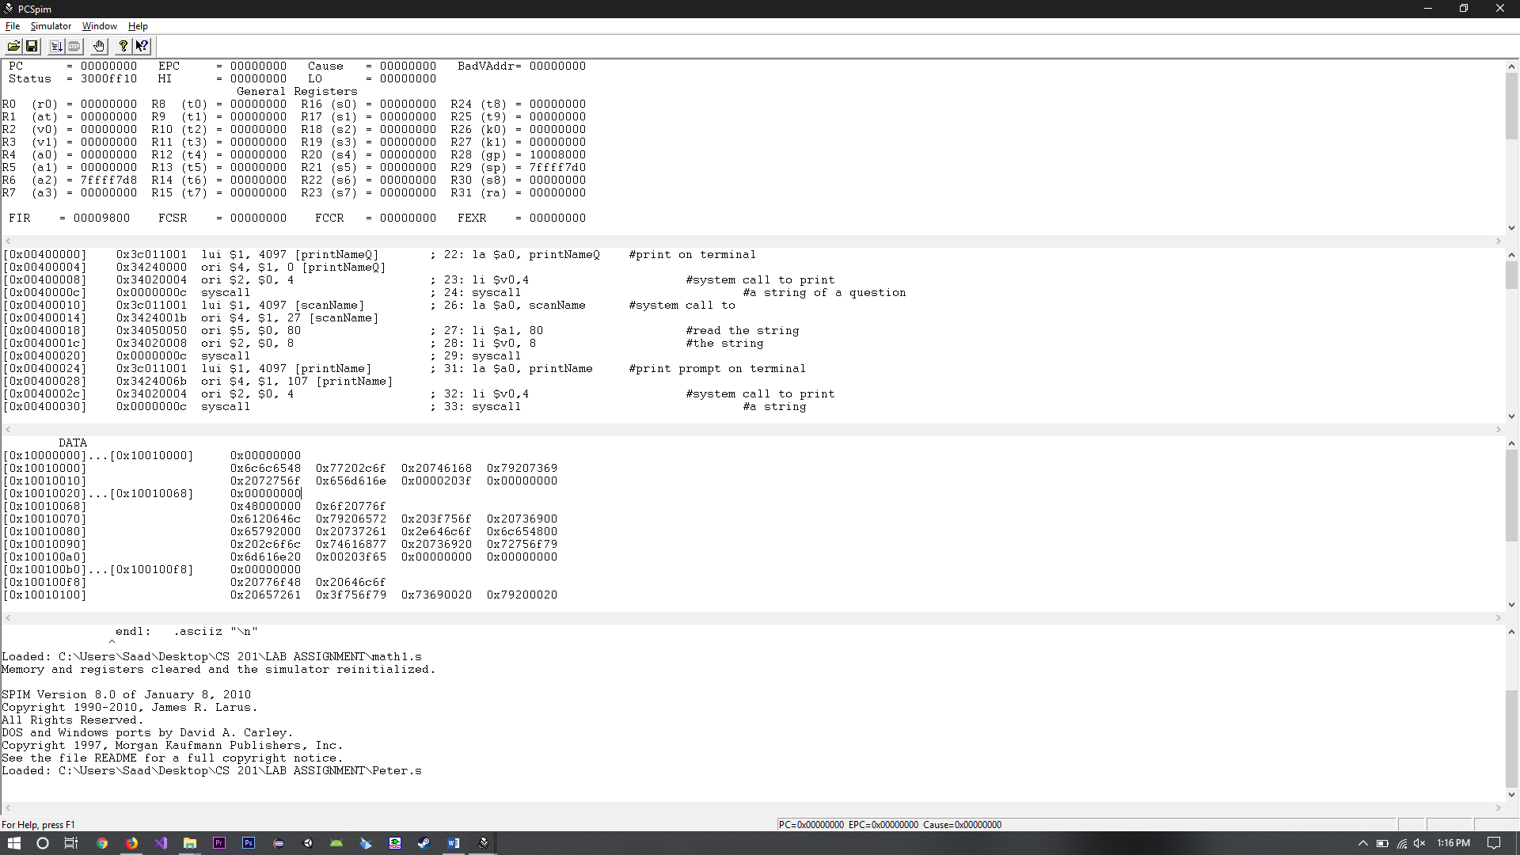

Results

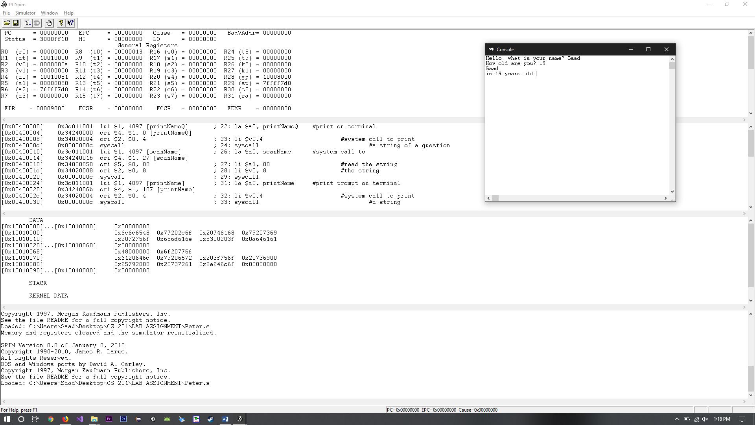

**Lab 4 (B) convertF2C.s**

Source Code

##

## The program --- convertF2C.s

##

## - will ask the user for temperature in Farenheit,

## - convert it to Celcius, and

## - print the result.

##

## Here is the formula of the conversion:

## C = (F - 32) * (5 / 9)

##

## v0 - reads in Farenheit

## t0 - holds Celcius result

## a0 - points to output strings

#################################################

# #

# text segment #

# #

#################################################

.text

.globl __start

__start: # execution starts here

la $a0,prompt #print prompt on terminal

li $v0,4 #system call to print

syscall #out a string

li $v0,5 #syscall 5 read an integer

syscall

addi $t0,$v0,-32 #to convert, add -32

mul $t0,$t0,5 #multiply by 5

div $t0,$t0,9 #divide by 9

la $a0,ans1 #print string before result

li $v0,4

syscall

move $a0,$t0 #print result

li $v0,1

syscall

la $a0,endl1 #syscall to print out

li $v0,4 #a new line

syscall

la $a0,endl2 #syscall to print out

li $v0,4 #a new line

syscall

li $v0,10

syscall #Bye!

#################################################

# #

# data segment #

# #

#################################################

.data

prompt: .asciiz "Enter temperature (Farenheit) : "

ans1: .asciiz "The temperature in Celcius is "

endl1: .asciiz "\n"

endl2: .asciiz "\n"

##

## end of file convertF2C.s

Successful Load

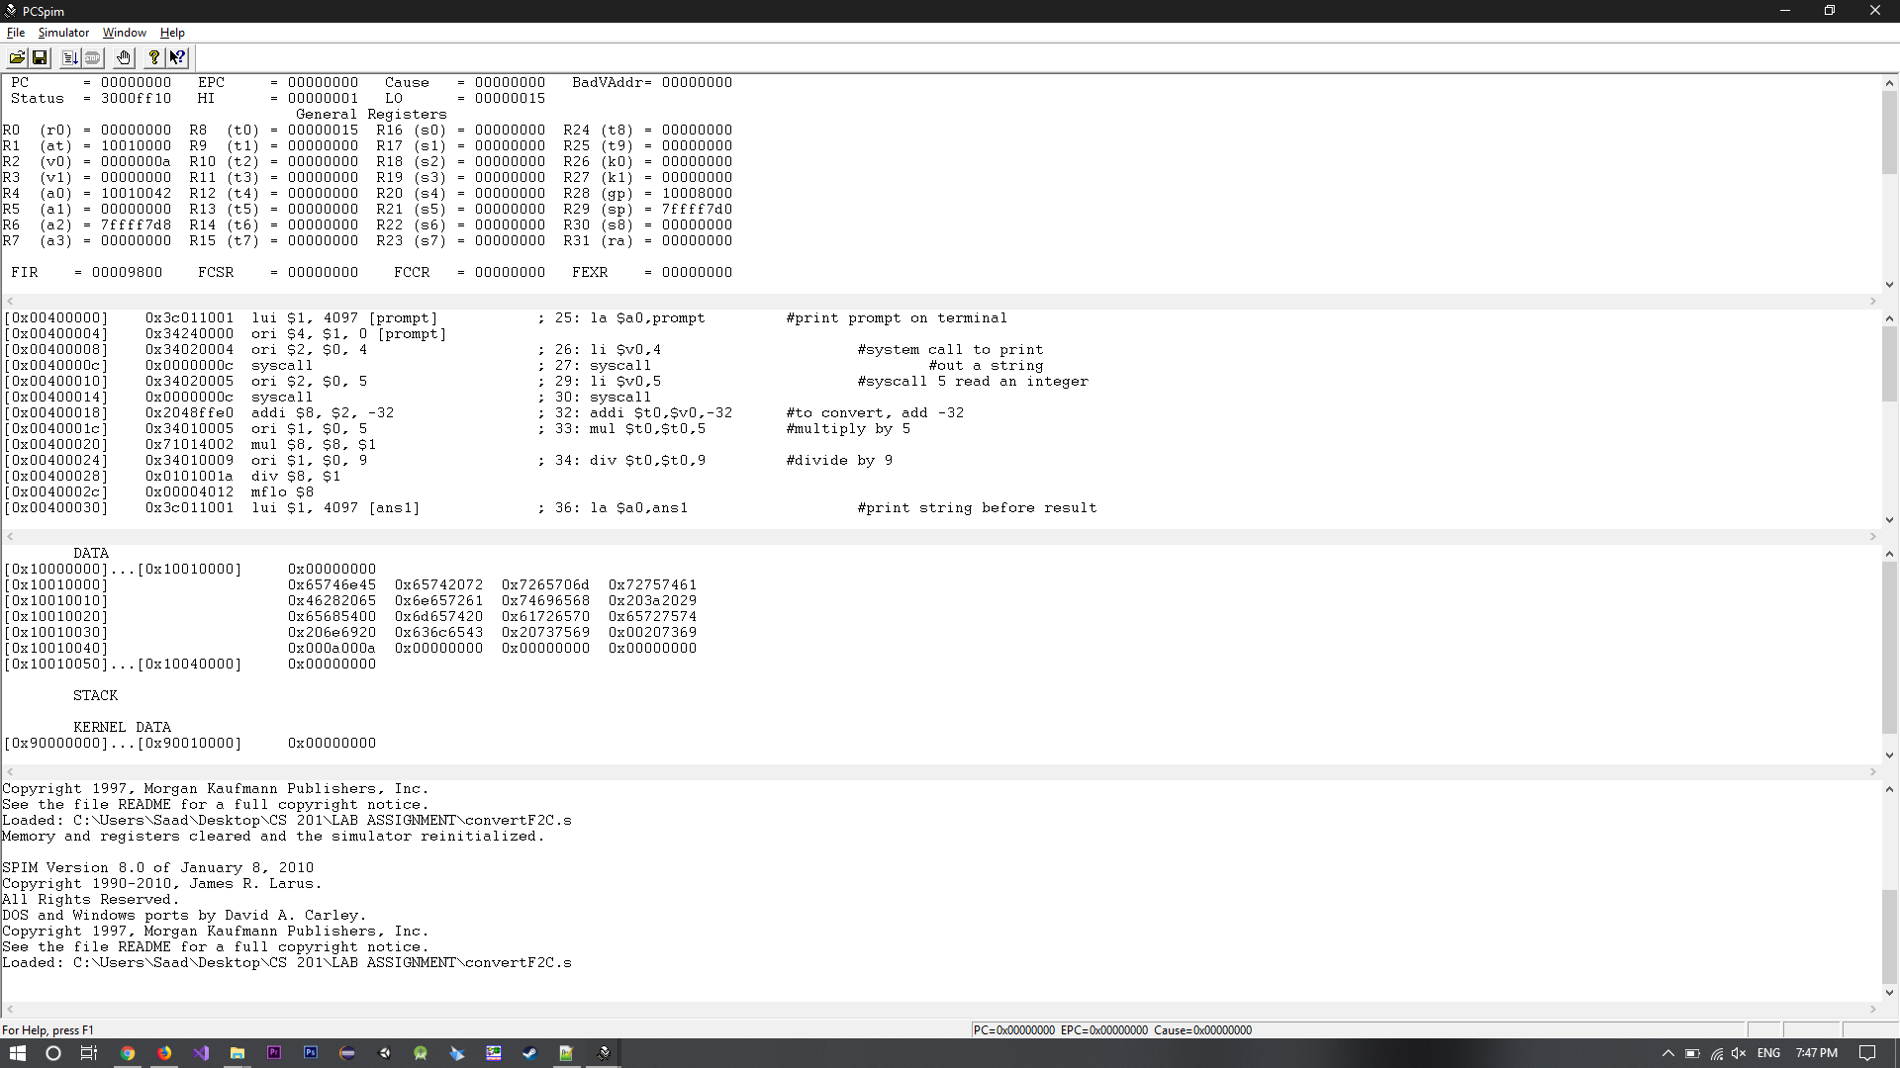

Results

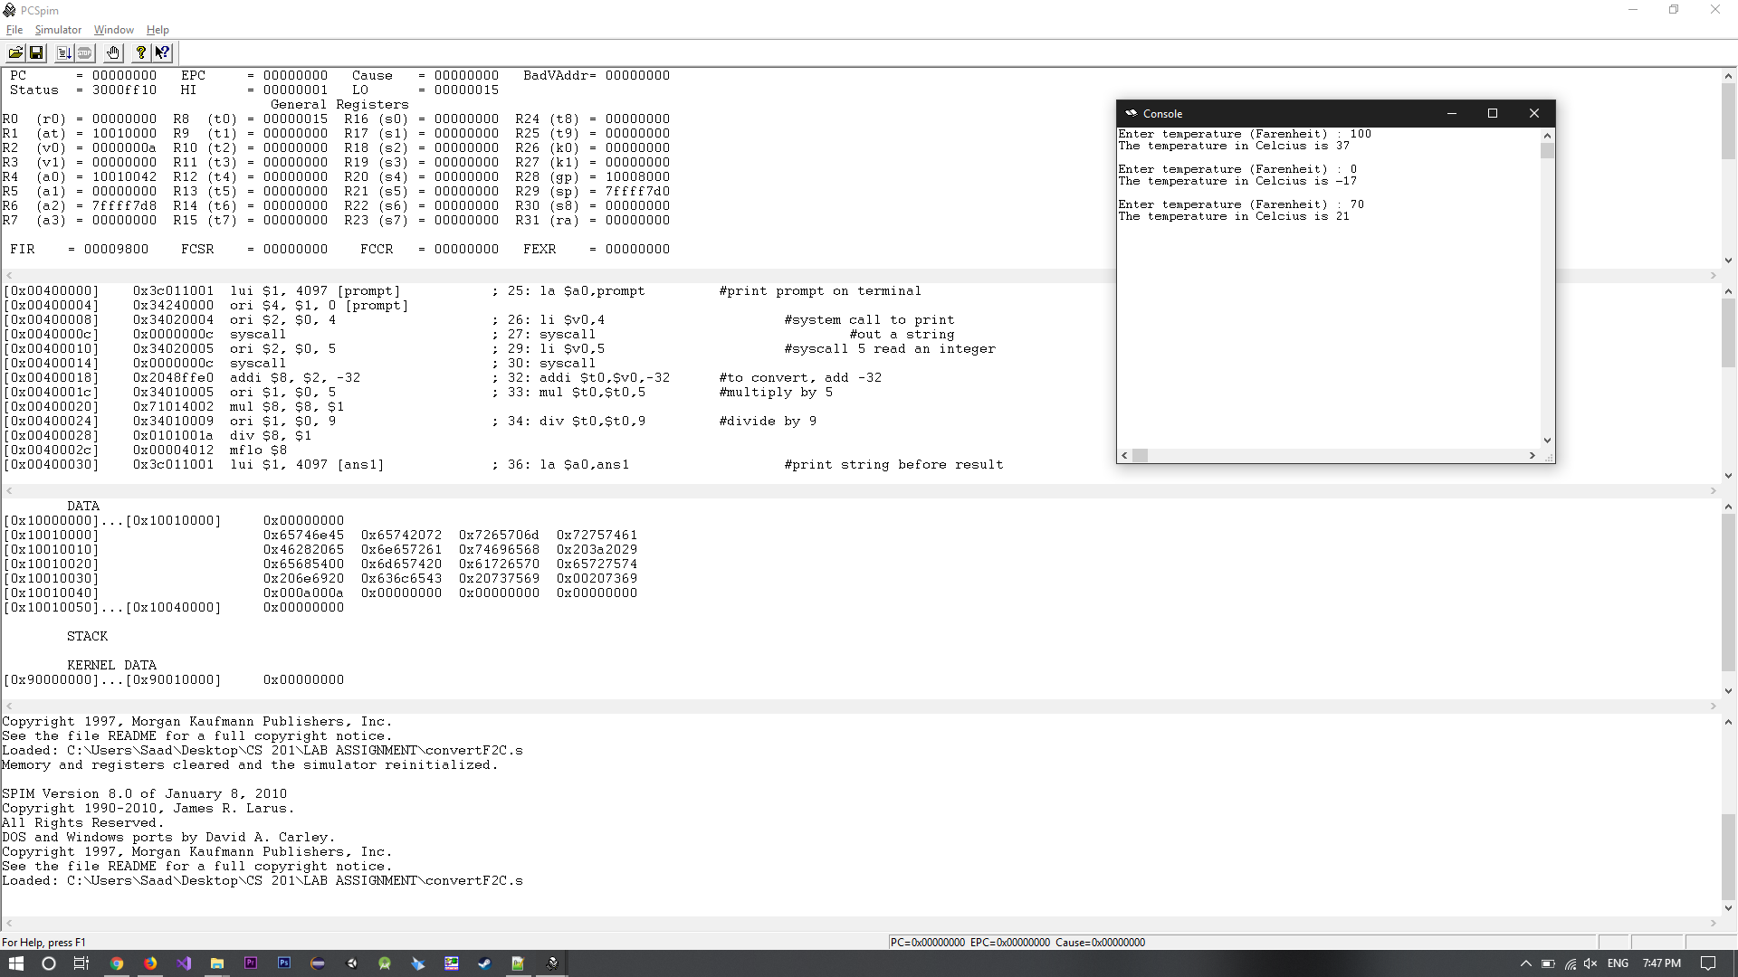

**Lab 4 (A) equation.s**

Source Code

##

## Program Name: equation.s

##

## - will calculate the value of

## - A*X^2+B*X+C and

## - print the result in format "Answer = 180".

##

##

## t1...3 - holds the result of the calculation

## a0 - points to output strings

##

#################################################

# #

# text segment #

# #

#################################################

.text

.globl __start

__start: # execution starts here

lw $t1,A

lw $t2,B

lw $t3,C

la $a0,prompt #print prompt on terminal

li $v0,4 #system call to print

syscall #out a string

li $v0,5 #system call to

syscall #read integer X

mul $t4,$v0,$v0 # t4 = X^2

mul $t4,$t4,$t1 # t4 = A*X^2

mul $t5,$t2,$v0 # t5 = B*X

add $t4,$t4,$t5 # t4 = A*X^2+B*X

add $t4,$t4,$t3 # t4 = A*X^2+B*X+C

la $a0,ans1 # print string before result

li $v0,4

syscall

move $a0,$t4 # print result

li $v0,1

syscall

la $a0,endl # syscal to print out

li $v0,4 # a new line

syscall

la $a0,endl # syscal to print out

li $v0,4 # a new line

syscall

li $v0,10 # Exit

syscall # Bye!

#################################################

# #

# data segment #

# #

#################################################

.data

A: .word 3

B: .word 4

C: .word 5

prompt: .asciiz "Enter the Value of X : "

ans1: .asciiz "Answer = "

endl: .asciiz "\n"

endl: .asciiz "\n"

##

## end of file equation.s

Successful Load

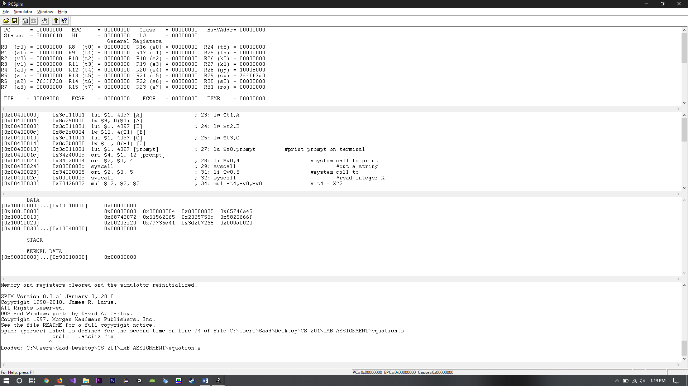

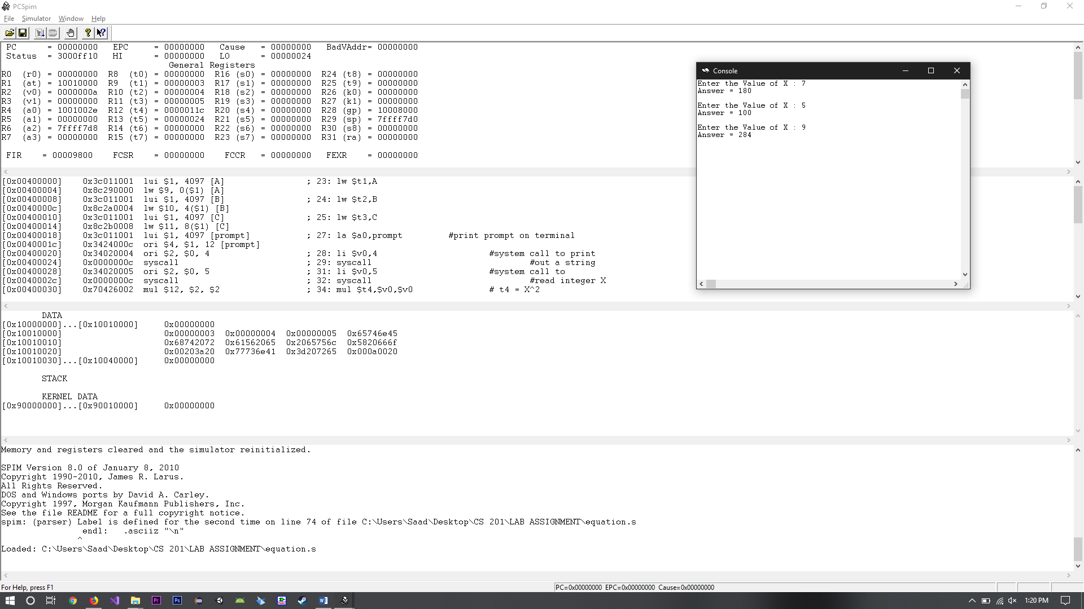Results